**Industrial Internship Report on**

**” IoT-Enabled Streetlight Management: Remote Monitoring and Optimization ”**

**Prepared by**

[Rahul Kumar]

|  |
| --- |
| *Executive Summary* |
| This report provides details of the Industrial Internship provided by upskill Campus and The IoT Academy in collaboration with Industrial Partner UniConverge Technologies Pvt Ltd (UCT).  This internship was focused on a project/problem statement provided by UCT. We had to finish the project including the report in 6 weeks’ time.  My project was -*IoT-Enabled Streetlight Management: Remote Monitoring and Optimization*  This internship gave me a very good opportunity to get exposure to Industrial problems and design/implement solution for that. It was an overall great experience to have this internship. |

**TABLE OF CONTENTS**

1 Preface 3

2 Introduction 7

2.1 About UniConverge Technologies Pvt Ltd 7

2.2 About upskill Campus 12

2.3 Objective 14

2.4 Reference 14

2.5 Glossary 15

3 Problem Statement 16

4 Existing and Proposed solution 17

5 Proposed Design/ Model 20

5.1 High Level Diagram (if applicable) 21

5.2 Low Level Diagram (if applicable) 22

5.3 Interfaces (if applicable) 22

6 Performance Test 24

6.1 Test Plan/ Test Cases 24

6.2 Test Procedure 24

6.3 Performance Outcome 24

7 My learnings 24

8 Future work scope 26

# Preface

**Summary of the whole 6 weeks’ work.**

Developing a streetlight monitoring system for Android necessitates the integration of diverse technologies, encompassing Android application design, IoT gadgetry, and communication protocols. The primary objective revolves around achieving remote streetlight status surveillance and streamlined operational oversight. The subsequent synopsis presents a comprehensive delineation of the stages implicated in the establishment of such a system:

1. Hardware setup:

Install IoT devices (like sensors or microcontrollers) on each streetlight. These devices should be capable of detecting the status of the streetlight (on/off), collecting data, and communicating with the Android app through the internet for that I used Arduino uno and ultra sensor for my project.

2.Server setup:

Set up a cloud server to collect and store data from the IoT devices. The server should be able to handle incoming data from streetlights LED and store them in a database for that I used firebase setup.

3. Android App Development:

Now Developing an Android app that serves as the user interface for the monitoring system. Users should be able to see the status of each streetlight and control them remotely.

4. Real-time Data Retrieval:

Here, I am Configure the Android app to subscribe to the Arduino uno codes where the IoT devices publish their status data. This way, the app can receive real-time updates about the streetlight LED as well as Distance sensor statuses.

5. Status Display:

Then I have design the app interface to display the status of each streetlight LED (on/off) with different colors button for easy visualization and Distance reading status.

6. Remote Control:

Now Implemented a features in the Android app that allow users to remotely control the streetlight LED This could include turning them on/off.

7. Testing and Deployment:

Thoroughly test the Android app and ensure that the communication between the app, server, and IoT devices is seamless. After testing, deploy the app on the Google Play Store or distribute it to the target users.

At last, ensuring that the communication between the Android app and the server is encrypted, and user data is protected. Additionally, checking for scalability to handle a growing number of streetlights and users in the future.

**About need of relevant Internship in career development.**

Participating in an Android internship significantly contributes to one's professional growth by furnishing invaluable practical insights and experiential learning in the realm of mobile app creation. These internships serve as a conduit for burgeoning developers to immerse themselves in tangible projects, grasp established industry norms, and collaborate harmoniously within teams. Guided by seasoned mentors, interns are empowered to refine their technical prowess and cultivate innovative thinking. Ultimately, Android internships pave the way for individuals to construct a robust groundwork, propelling them toward triumph in the perpetually advancing domain of mobile technology.

**Brief about Your project/problem statement.**

The synopsis of implementing the "Street Light Monitoring System" on Android, incorporating a distance sensor, entails the creation of a mobile application. This app will seamlessly interface with the distance sensor, furnishing a platform for overseeing and governing street light operations. It encompasses both control features and monitoring capabilities, ensuring efficient and effective management of the street lighting infrastructure.

**Opportunity given by USC/UCT.**

My tenure as an Android development intern was truly a remarkable experience within the multifaceted and ever-evolving domain. The developmental journey encompassed a harmonious synergy amongst Android app developers, sensor connoisseurs, and system integration specialists, all converging to craft a resilient and impactful resolution. This collaborative effort culminated in the establishment of a potent and efficient solution, underscoring the significance of teamwork in achieving technological excellence.

**How Program was planned**



**Your Learnings and overall experience.**

Participating in the realm of Android development has undoubtedly been an enriching chapter in my journey. I am immensely grateful for the opportunity to delve into this versatile and dynamic field, where innovation knows no bounds. I extend my heartfelt gratitude to everyone who has been a part of this remarkable venture, particularly my teacher and mentor, Saumya Singh, and Joyti ma’am, whose guidance has been invaluable.

To my fellow juniors and peers,

I wish to share my insights garnered from my Android development internship. This transformative experience has been a true milestone, enriching my skill set and unfurling a myriad of prospects within the tech industry. Throughout the course of this internship, I absorbed practical knowledge, embarked on tangible projects, and collaborated closely with seasoned mentors. This invaluable exposure bolstered my confidence and honed my prowess in the realm of Android development.

I enthusiastically urge each one of you to contemplate embarking on an Android internship. This endeavor promises not only to elevate your technical proficiencies but also to lay a sturdy groundwork for a thriving career in the realm of mobile app creation. Embrace challenges with an open heart, cultivate an unwavering curiosity, and commit to perpetual learning. Together, let's harness the ever-evolving landscape of Android development to its utmost potential!

Well wishes,

Rahul Kumar

# Introduction

## About UniConverge Technologies Pvt Ltd

A company established in 2013 and working in Digital Transformation domain and providing Industrial solutions with prime focus on sustainability and RoI.

For developing its products and solutions it is leveraging various**Cutting Edge Technologies e.g. Internet of Things (IoT), Cyber Security, Cloud computing (AWS, Azure), Machine Learning, Communication Technologies (4G/5G/LoRaWAN), Java Full Stack, Python, Front end**etc.



1. UCT IoT Platform **(****)**

**UCT Insight** is an IOT platform designed for quick deployment of IOT applications on the same time providing valuable “insight” for your process/business. It has been built in Java for backend and ReactJS for Front end. It has support for MySQL and various NoSql Databases.

* It enables device connectivity via industry standard IoT protocols - MQTT, CoAP, HTTP, Modbus TCP, OPC UA
* It supports both cloud and on-premises deployments.

It has features to  
• Build Your own dashboard  
• Analytics and Reporting  
• Alert and Notification  
• Integration with third party application(Power BI, SAP, ERP)  
• Rule Engine

 

1. **Smart Factory Platform (****)**

Factory watch is a platform for smart factory needs.

It provides Users/ Factory

* with a scalable solution for their Production and asset monitoring
* OEE and predictive maintenance solution scaling up to digital twin for your assets.
* to unleased the true potential of the data that their machines are generating and helps to identify the KPIs and also improve them.
* A modular architecture that allows users to choose the service that they what to start and then can scale to more complex solutions as per their demands.

Its unique SaaS model helps users to save time, cost and money.

 

1.  based Solution

UCT is one of the early adopters of LoRAWAN teschnology and providing solution in Agritech, Smart cities, Industrial Monitoring, Smart Street Light, Smart Water/ Gas/ Electricity metering solutions etc.

1. Predictive Maintenance

UCT is providing Industrial Machine health monitoring and Predictive maintenance solution leveraging Embedded system, Industrial IoT and Machine Learning Technologies by finding Remaining useful life time of various Machines used in production process.



## About upskill Campus (USC)

upskill Campus along with The IoT Academy and in association with Uniconverge technologies has facilitated the smooth execution of the complete internship process.

USC is a career development platform that delivers **personalized executive coaching** in a more affordable, scalable and measurable way.



Seeing need of upskilling in self paced manner along-with additional support services e.g. Internship, projects, interaction with Industry experts, Career growth Services

<https://www.upskillcampus.com/>

upSkill Campus aiming to upskill 1 million learners in next 5 year



## The IoT Academy

The IoT academy is EdTech Division of UCT that is running long executive certification programs in collaboration with EICT Academy, IITK, IITR and IITG in multiple domains.

## Objectives of this Internship program

The objective for this internship program was to

 ☛ get practical experience of working in the industry.

 ☛ to solve real world problems.

 ☛ to have improved job prospects.

 ☛ to have Improved understanding of our field and its applications.

 ☛ to have Personal growth like better communication and problem solving.

## Reference

* <https://www.geeksforgeeks.org/>
* https://www.upskillcampus.com/
* <https://developer.android.com/studio>
* <https://developer.android.com/>
* https://thingspeak.com/

## Glossary

|  |  |
| --- | --- |
| Terms | Acronym |
| UCT | Uni converge Technologies |
| EICT | Electronic and Information Communication Technology. |
| IITK | Indian Institute of Technology Kanpur |
| IITR | Indian Institute of Technology Roorkee |
| IITG | Indian Institute of Technology Guwahati |

# Problem Statement

In the assigned problem statement

The problem statement mentions a "Street Light Monitoring System" with a distance sensor. This system is likely designed to monitor and control street lights in a more efficient and automated manner.

The system's purpose might be to adjust the lighting intensity or timing of the street lights based on the data collected from the distance sensor. For instance, if the distance sensor detects no activity or traffic in a certain area, the system might dim or turn off the street lights to save energy. Conversely, when the distance sensor detects activity, it could increase the brightness or turn on additional lights to ensure adequate visibility and safety.

**Develop a project related to the Street Light Monitoring System in form of Android Application.**

# Existing and Proposed solution:

To embark on the development of a smart streetlight IoT device project, several key steps need to be undertaken:

1. **Select an IoT Platform:** Opt for an IoT platform that suits your project's needs. Diverse platforms like AWS IoT, Azure IoT Suite, and Google Cloud IoT Core offer secure and scalable connectivity for IoT devices. These platforms facilitate the creation, deployment, and management of IoT solutions.

2. **Architect the System:** Create a robust system architecture that outlines how various system components will communicate. Scalability, reliability, and security should be at the core of this design.

3. **Craft Hardware:** Develop the streetlight unit and incorporate sensors and actuators. The streetlight must be internet-enabled, capable of bidirectional data exchange. Sensors and actuators should efficiently gather environmental data and manage streetlight functions.

4. **Integrate MQTT and LoRaWAN:** Combine MQTT (a lightweight messaging protocol) with LoRaWAN (low-power wide-area network) technology for efficient data transfer from sensors to the cloud. This amalgamation facilitates data collection and cloud-based analytics.

5. **Create a Mobile App:** Design a mobile application empowering users to remotely control the streetlight. This app should connect with the IoT platform, enabling command transmission and data display from sensors.

6. **System Deployment:** Roll out your comprehensive solution by configuring the IoT platform, setting up hardware components, and launching the mobile app. The cloud server will store, process, and relay data, as well as enable remote streetlight control.

Integration of MQTT and LoRaWAN entails:

- MQTT: A lightweight, efficient messaging protocol suitable for IoT applications.

- LoRaWAN: Low-power, long-range communication technology.

- Combined, they enable sensor data transmission to the cloud for analysis, reporting, and energy usage tracking.

Essential Features:

- User-Controlled Streetlight: Grant users diverse control over streetlight functions, including on/off operation.

- Sensor Data Display: Allow users to access and view sensor-derived data, such as distance measurements.

Software Stack:

- Front-end: Swift (for iOS), Java (for Android), React Native, Flutter

- Back-end: Node.js, Python, Java

- Database: Opt for a cloud-based database solution.

- APIs: Integrate external services/APIs, such as weather and water quality data.

- Data Visualization: Utilize visualization libraries like ECharts, Highcharts, or Google Charts.

In essence, the streetlight control page serves as a valuable tool, empowering users to efficiently manage streetlights, thereby contributing to energy conservation and efficient urban lighting management.

## Code submission (Github link)

https://github.com/Rahul303021y/UpSkill_Campus.git

## Report submission (Github link) :

<https://github.com/Rahul303021y/UpSkill_Campus.git>

# Proposed Design/ Model

1. Street Light Monitoring System: This refers to an overall system that monitors and controls street lights. It could include various sensors, control units, and communication modules to achieve its objectives.
2. Distance Sensor: The system incorporates a distance sensor. This type of sensor is used to measure the distance of objects or obstacles in its vicinity. In the context of the Street Light Monitoring System, the distance sensor could be utilized to detect the presence of vehicles, pedestrians, or any other objects in the proximity of the street lights.

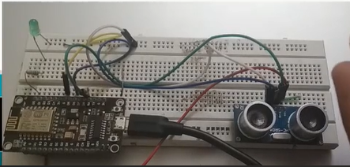

Arduino uno

Off LED

Ultra sensor

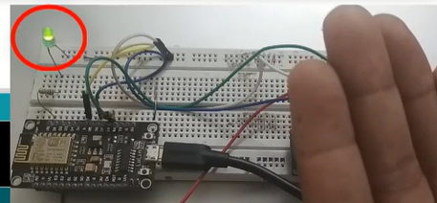

On LED

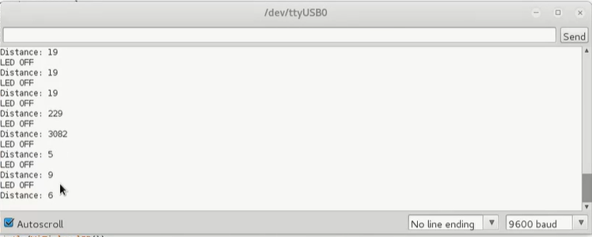

## High Level Diagram (if applicable)

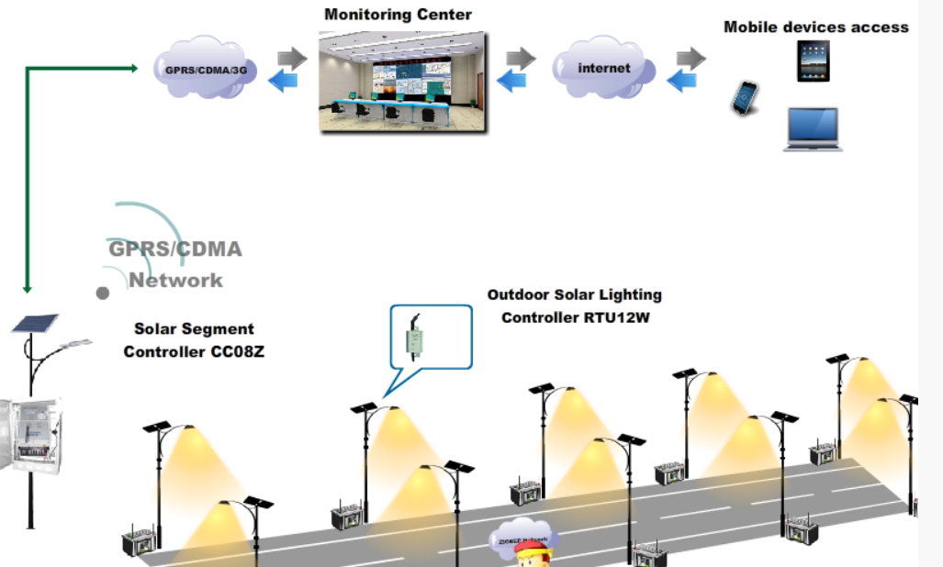

Figure 1: HIGH LEVEL DIAGRAM OF THE SYSTEM

## Low Level Diagram (if applicable)

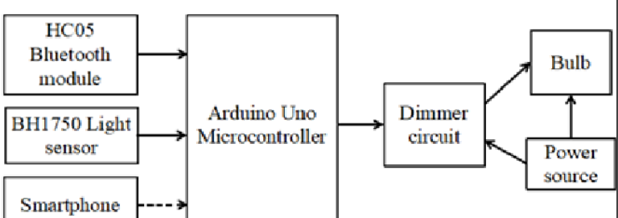

## Interfaces (if applicable)

Update with Block Diagrams, Data flow, protocols, FLOW Charts, State Machines, Memory Buffer Management.

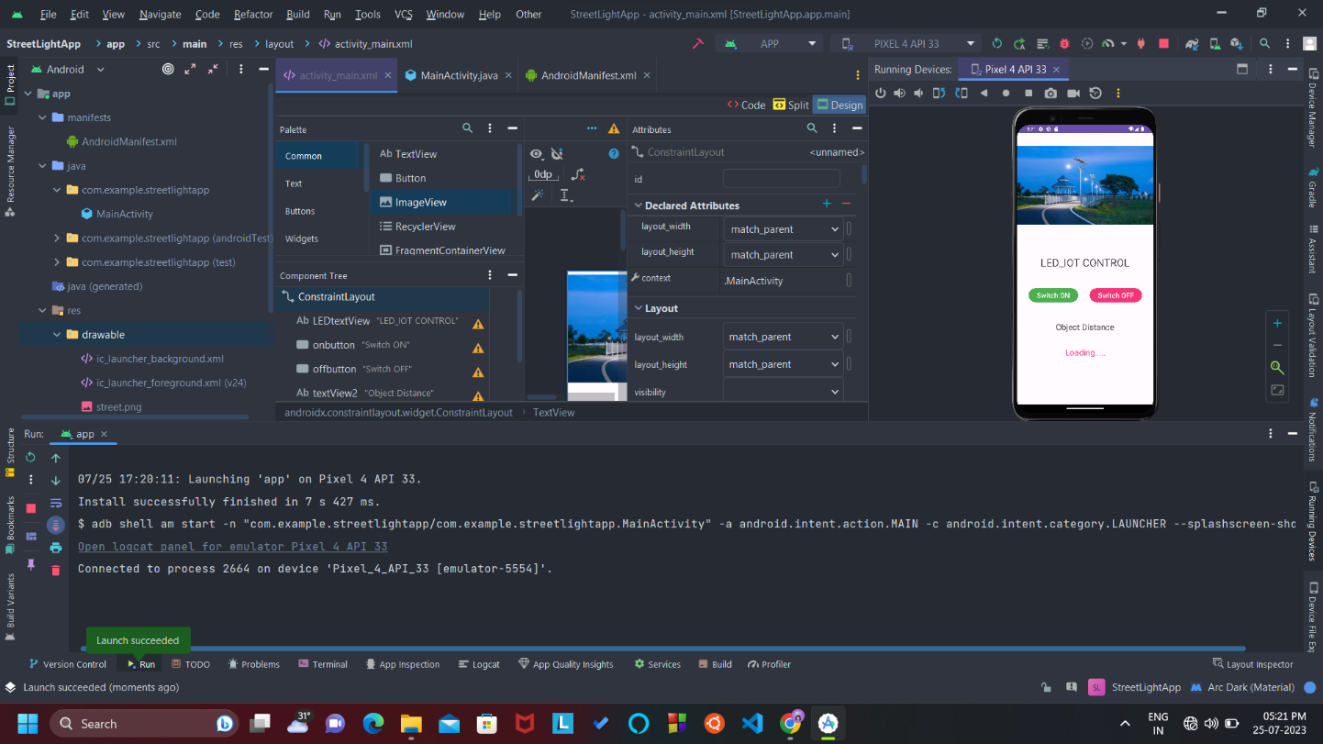

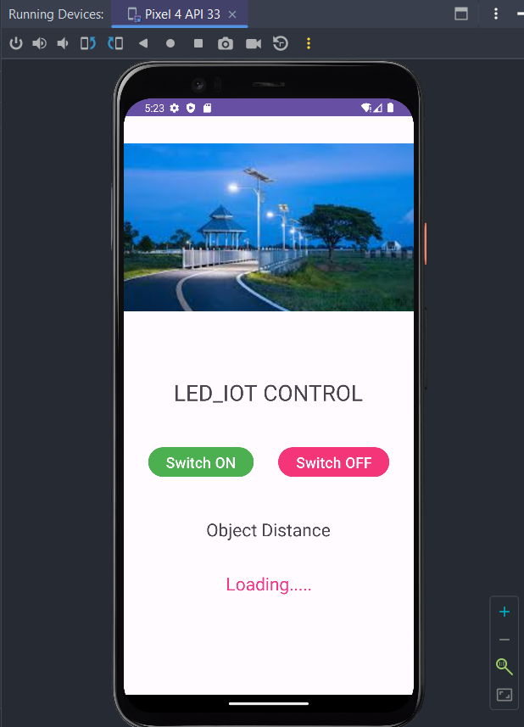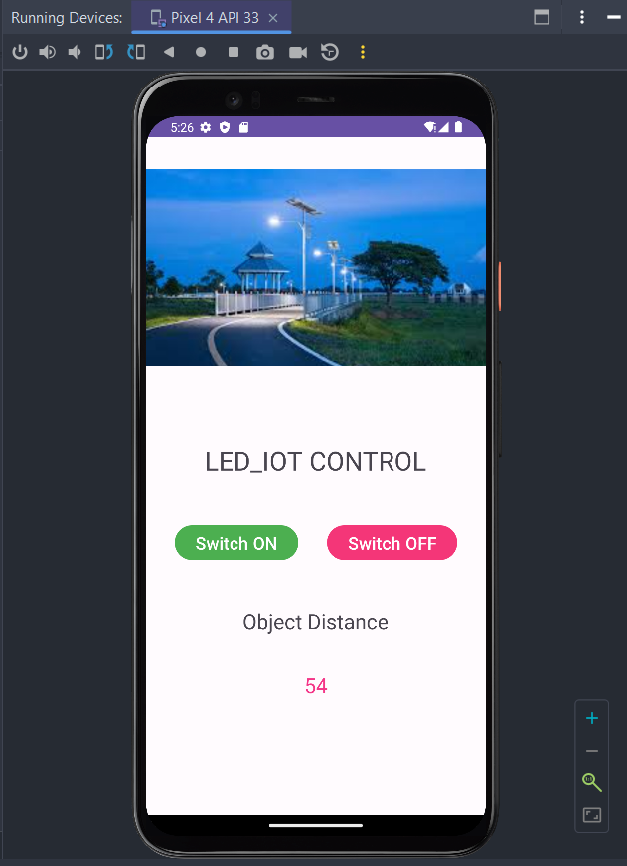

# Performance Test

This is very important part and defines why this work is meant of Real industries, instead of being just academic project.

Here we need to first find the constraints.

How those constraints were taken care in your design?

What were test results around those constraints?

Constraints can be e.g. memory, MIPS (speed, operations per second), accuracy, durability, power consumption etc.

In case you could not test them, but still you should mention how identified constraints can impact your design, and what are recommendations to handle them.

## Test Plan/ Test Cases

## Test Procedure

## Performance Outcome

# My learnings

From the description of the "Street Light Monitoring System" with a distance sensor, there are several key learnings that can be drawn:

Internet of Things (IoT) Applications:

The project highlights the application of IoT principles in real-world scenarios. By using sensors like distance sensors, the street light system can collect data and make intelligent decisions to optimize street light operations.

Energy Efficiency:

Implementing distance sensors can lead to energy-efficient solutions. By dimming or turning off street lights when there is no activity or traffic, energy consumption can be reduced, resulting in cost savings and a positive environmental impact.

Automation and Control:

The project involves automation and control systems that can adjust street lighting based on real-time data. Automation allows for more efficient and accurate responses to changing conditions, reducing the need for manual intervention.

Safety and Public Services:

Street lighting is crucial for public safety and security. By monitoring the environment with distance sensors, the system can ensure that appropriate lighting levels are maintained to enhance pedestrian and vehicular safety.

Data-Driven Decision Making:

The project demonstrates the significance of data-driven decision making. Analyzing data from the distance sensor allows the system to respond dynamically to different situations, making it more adaptive and responsive.

Interdisciplinary Nature of Projects:

A project like this involves multiple disciplines, including electronics, sensors, data analysis, software development, and communication protocols. Collaborating across these disciplines is essential for successful project implementation.

Environmental Impact: By reducing energy consumption through better lighting management, the project contributes to minimizing the environmental footprint. This showcases how technology can play a role in sustainability efforts.

Real-World Application:

The project is an example of a practical application of technology in everyday life. It illustrates how innovations can be utilized to improve existing systems and infrastructure.

Challenges and Limitations:

While distance sensors can offer many benefits, there might be challenges such as sensor accuracy, data interpretation, and potential false positives/negatives. Addressing these challenges requires careful calibration and testing.

# Future work scope

Future Scope:

The project may inspire further developments and improvements in street lighting systems. For instance, integrating additional sensors like motion sensors or cameras could enhance the system's capabilities for even better monitoring and control.

Overall, the "Street Light Monitoring System" with a distance sensor serves as a valuable example of how technology can be harnessed to create smarter, more efficient, and sustainable solutions for public infrastructure. It also emphasizes the importance of considering environmental and societal impacts in technological innovations.